Wearable and flexible technologies enabled by advanced thin-film manufacture and metrology

ANNUAL REPORT No. 2
May 2016– April 2017

WAFT Project (2015-2020)
We aim to accelerate the development of wearable and flexible technologies by integrating device component develop-ment using advanced functional materials along with scalable, cost-effective and reliable manufacturing techniques.

Most research across the world for new device materials remained, for the time being, focused at laboratory scale, and there is a window of opportunity to develop a manufacturing lead in this area.

Featured success of the 2nd year:

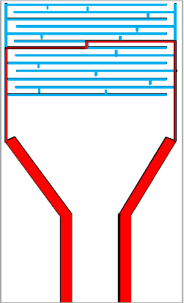
Interdigitated Electrodes as Substrates (microgaps)

Featured method of the 2nd year:
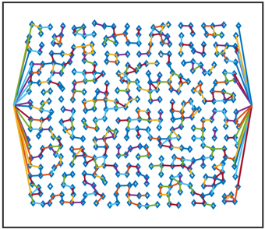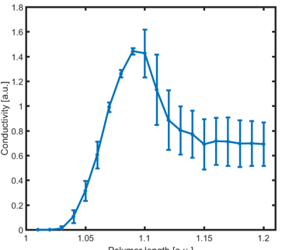
We use modelling to optimize devices, i.e. reduce properties variability from one device to another.
20 by 20 percolation network connected to electrodes conductivity of the as fabricated sensor vs polymer length.

Key findings for 2016-2017:
1) Development of gray scale in displays using growth dominated materials.
2) Refinement of sensor technologies using percolation sensors
3) Development of new manufacturing processes for flexible manufacturing of sensors.
4) Development of models for optimization of device parameters across a range of devices
5) Development of a library of refractive indexes for in-situ metrology during deposition.
6) Established CVD processes for Chalcogenides and Emerging Materials.

Featured equipment of the 2nd year:

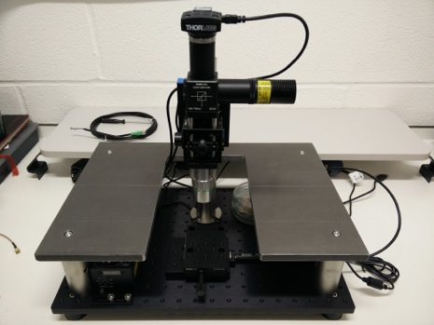
Probe station to measure both the electrical and optical characteristics of flexible and wearable optoelectronic devices.

WAFT Facts 2016-2017

1) Close teamwork of the research groups:
=> Oxford-Exeter model to predict sensors properties.
=> Southampton-Exeter: optimization and design of novel thermoelectric devices, and atomistic simulations to design thermoelectric materials with enhanced properties.
=>Oxford-Southampton-Bodle: SRD development, handling leaking dielectrics.
=> Oxford Physics-Materials: metrology of display and sensor devices.
=> Oxford-Exeter: PCM manufacturing in larger scale.

2) Widening Industrial Advisory Board with increased number of Industrial Partners from 15 to 18. Project updates are provided to 28 WAFT industrial collaborators and EPSRC portfolio representatives.

9 research investigators, 15 postdoctoral associates, 14 doctoral researchers, 2 undergraduate researchers, 3 laboratory technicians contributed to the 11 WAFT research strands.

83 journal articles, conference proceedings and science posters make up WAFT publication list in April 2017.

John Yarwood Memorial Medal was awarded to Martin Castell for meritorious contributions to surface science.
Moritz Riede was invited to the Advisory Board of Sustainable Energy & Fuels

The WAFT project will run until April 2020 as the 1-year, no cost extension was approved by EPSRC (EP/M015173/1).

Creativity and Further Funding:
- MC EPSRC iCASE with Dstl
- MC Newton Fund, British Council Funding to extend percolation gas sensing work for land mine detection in Columbia
- MR Fellowship
- HB Fellowship extension
- HB, DH Innovate UK with Bodle
- HB, BC EPSRC Designing Nanosystems: the CMOS way.

International collaborations:
3 UK university partners in the consortium with 2 universities as international partners are delegating 44 academic collaborators into the project.
18 industrial partners with their 28 industrial collaborators are supporting the international WAFT research.
WAFT PART-NERS | Academic/  University |  | Industry/  Private
 | in 2015 | in  2016 | in  2015 | in  2017
UK | 3 | 3 | 5 | 10
EU | 1 | 1 | 2 | 6
USA | 1 | 1 |  | 2
Total | 5 | 5 | 7 | 18

Collaboration:
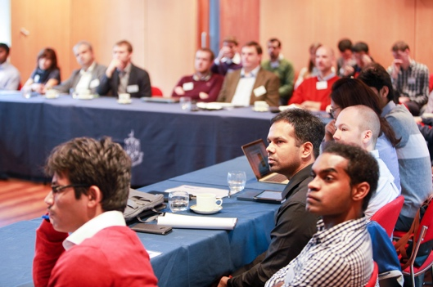
Figure 1 The first WAFT Scientific Meeting welcomed 55 attendees on 20 October 2017.

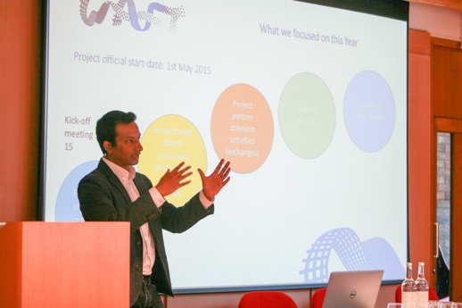Figure 2 The PI provided highlights of the WAFT project to the academic and industrial collaborators
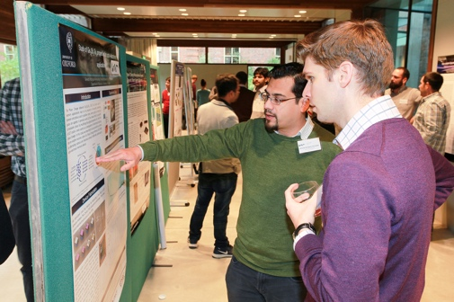
Figure 3 The 13 research posters enabled vibrant discussions of academics, students, postdocs and industrial advisors.
Figure 4 The Somerville College provided atmospheric meeting venues over two days.
WAFT Industrial Partners:
Defence Science & Tech Lab (Detection), BASF AG, CreaPhys GmbH, Kurt J Lesker Co Ltd, Asylum Research (USA), Sharp Laboratories of Europe Ltd, Centre for Process Innovation Ltd, Fraunhofer FEP, IBM Research – Zurich, CSEM SA, Oxford Instruments, Asylum Research (UK), Bodle Technologies Ltd, Oxford PV, Heliatek GmbH, PragmatIC Ltd, Eckersley O’Callaghan, Plasma App Ltd.

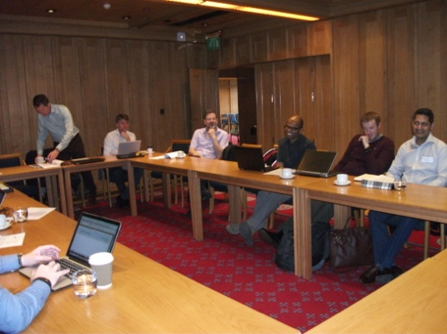
Figure 5 Discussions at the IAB meeting on 21 October 2017
WAFT Academic Partners:

International Academic Partners:
- Karlsruhe Institute of Technology (Institute of Nanotechnology),
- University of Pennsylvania (Mechanical Engineering)

Dissemination:
- WAFT project website - revamped:
www.waftcollaboration.org
- Presentation highlight: Hazel E. Assender: Roll-to-roll manufacture of all-evaporated organic circuits for flexible electronics, Printed and Flexible Electronics Congress 2017, 21-22 February, London, UK

Publication highlights:
- C. Ríos, P. Hosseini, R. A. Taylor, and H. Bhaskaran, "Color Depth Modulation and Resolution in Phase-Change Material Nanodisplays." Advanced Materials, (2016), 1-7., DOI: 10.1002/adma.201506238, WILEY-VCH Verlag GmbH & Co.
- S. G.-C. Carrillo, G. R. Nash, H. Hayat, M. J. Cryan, M. Klemm, H. Bhaskaran and C. D. Wright, "The design of practicable phase-change metadevices for near-infrared absorber and modulator applications." (2016), Optical Society of America
- C. Ríos, "Growth and nucleation dominated phase-change materials for nano-optoelectronics and display technology." INC11 Best Poster Award – Europe (2015)
- M. J. Lefferts and M. R. Castell, "Vapour sensing of explosive materials." Analytical Methods vol. 7 Issue 21, (Sept. 2015), 9005-9017., DOI: 10.1039/c5ay02262b, Royal Society of Chemistry
- P. Hosseini; H. Bhaskaran, "Colour performance and stack optimisation in phase change material based nano-displays." SPIE 9520, Integrated Photonics: Materials, Devices, and Applications III, (2015), 95200m., (June 1, 2015), DOI: 10.1117/12.2178658 (2015), SPIE Digital Library

Research Progress:

WP1. Metrology and Process Control for Waste Reduction

S1.1. In-situ Metrology Solutions for Thin Film Manufacturing

Co-Investigator: Moritz Riede,
PDRA: Sameer Vajjala Kesava.

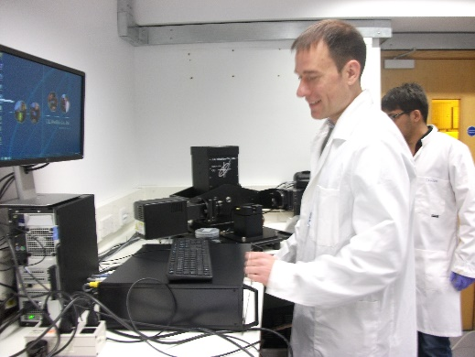
Figure 4 ????.
In-situ film thickness measurements: the ellipsometer seems to work well and Sameer has demonstrated that he can monitor in-situ the film thickness of several layers.

S1.2 Ex-situ Metrology and Characterization

Principal Investigator: Harish Bhaskaran
PDRAs: Nathan Youngblood, Zengguang Cheng, Carlos Rios Ocampo
Undergraduate researcher: Takashi Lawson

Nathan is in the process of building a custom probe station which has the ability to measure both the electrical and optical characteristics of flexible and wearable optoelectronic devices. Unique to this probe station is the ability to couple a laser or LED source to the optical path and probe a device’s response to various wavelengths of light. Additionally, a motorized linear stage can be computer controlled to automatically measure the electrical properties of flexible devices under stress. This will be useful to determine the robustness of flexible electronics after multiple bending or stretching cycles.

S1.3. Waste Reduction

Co-Investigator: Moritz Riede
PDRA: Sameer Vajjala Kesava

Monitoring of material usage for each deposition was started, building broader database for material usage. The relationship between material usage, processing conditions and device performance should be obtained to improve process control and mechanical design.

WP2. Flexible and Functional Components

2.1. Flexible Display

Principal Investigator: Harish Bhaskaran
PDRA: Nathan Youngblood, Zengguang Cheng, Carlos Ríos,
PhD students: Gerardo Rodriguez-Hernandez and Ghazi Sarwat; Undergrad. researcher: Takashi Lawson.

50 nm pixels! – Harish’s team started with their word record smallest display pixels demonstrated for potential application in projection-based displays as required for wearables. They developed transparent–electrode-based display in phase change materials with functional layer under 7 nm. The focus was changed to enable grey scale with very high resolution: 50 nm pixels.

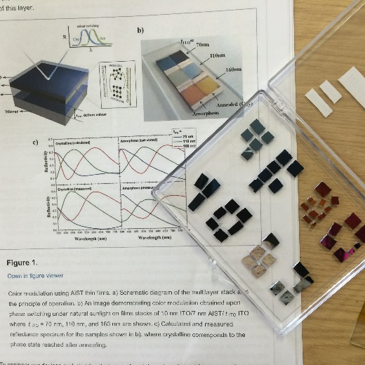
Figure 8 Some of the colourful samples from the latest result using new chalcogenides.
S2.2. Sensors

Co-Investigator: Martin R Castell,
PDRA: Krishnan Murugappan, PhD student: Merel Lefferts,
Ben Armitage, Tabitha Jones

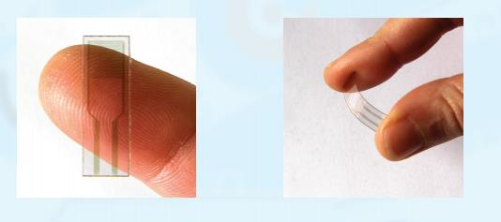
Figure 9 ????
Successfully electropolymerised conducting polymers on interdigitated electrodes (IDEs) which were stable over time
- Determined the percolation threshold of PEDOT on IDEs with micrometer sized gaps
- Successfully polymerised conducting polymers between gold nanoparticles on IDEs
- Determining the percolation threshold of the conducting polymer and gold nanoparticle network
- Electropolymerisation with a range of different polymers.

S2.3. Thermoelectric Energy Harvesting Module

Co-Investigator: Dan Hewak
Research fellows:
Kevin Huang Chung-Che, Ioannis Zeimpekis; PDRA: Katrina Morgan;
Research technician: Cris Craig;
PhD students: Nikos Aspiotis, Ghadah Alzaidy.

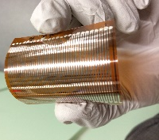
Figure 11 ….
Dan’s team is developing a thermo-electric module, complementing the organic photovoltaics as a secondary energy source. Flexibility limits the substrate material choice. Kevin deposited successfully BiSbTe and BiTe thin films by RF sputtering on polyimide at temperatures below 200 ºC. Demonstrated p-type and n-type Ga:La:S thin films and reported on feasibility in thermoelectric devices.

S2.4. Organic Photovoltaic Energy Harvesting Module

Co-Investigator: Moritz Riede,
PDRA: Sameer Vajjala Kesava.

Sameer and I had recently a meeting with Bhaskar about what electronics
we can drive with our organic solar cells. Bhaskar emailed last week
that he has an idea for a circuit….

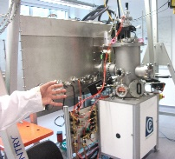
Figure 12 A CreaPhys Vaccuum deposition Tool in Riede's Lab

WP3. Integration, Modelling and Reliablilty

S3.1. Modelling - large-scale as well as atomic scale of variations

Co-Investigators: C. David Wright, Gino Hrkac.
PDRA: Arseny Alexeev, Lalita Saharan; PhD student: Santiago Garcia-Cuevas Carillo, Karthik Nagareddy, Carlota Ruiz de Galarreta

David’s team supported the development of organic thin film percolation sensors (WP2, S2.2) by creating semi-analytical model to predict sensors properties and performance and help analyse experimental results.

They also focused on supporting development of flexible thermoelectric device for energy harvesting (WP2, S2.3):
optimization and design of novel thermoelectric devices based on chalcogenide materials using finite-element modelling.
Gino and Lalita drove the atomistic simulations to design thermoelectric materials with enhanced properties.

S3.2. Design for Manufacturing and Reliablilty Modelling

Co-I: Bhaskar Choubey
PDRA: will start in May 2017
Bhaskar’s team aims to establish rule-based strategies for thin film device manufacturing and identify system circuit configurations for coping with variability for truly wearable systems.

They will also study the lifetime failure of functional devices. Discussions started with Harish’s display, Moritz’s solar cell and Martin’s sensor development specialists to see when they will reach a certain maturity with their devices for the engineering team to pick up the devices for testing and modelling their variability and reliability.

WP4. Scale-up via Roll-to-Roll Manufacturing

S4.1. Roll-to-Roll Process Development
Co-Investigator: Hazel E. Assender
Lab Technicians: Richard Turner, Clara Barker, PhD students: Thomas Cosnahan
Kai Zhang, Carmen Alonso-Herr

Hazel started discussions with WP1 and WP2 researchers about upscaling issues of roll-to-roll manufacturing of ultrathin films of highly functional materials.

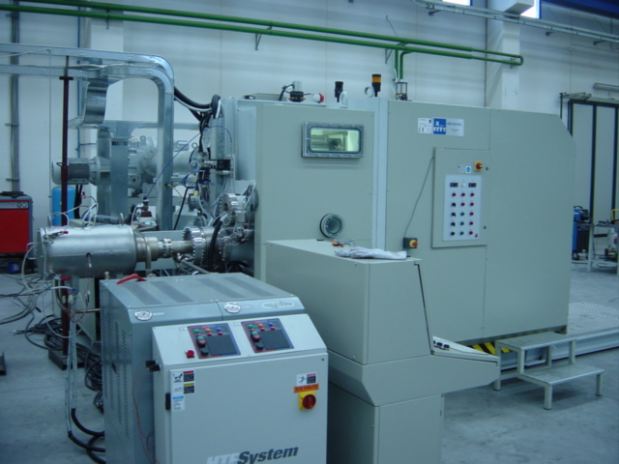
Figure 13 Assender's Roll-to-Roll Deposition Tool in Begbroke Science Park

S4.2. Device Fabrication using Roll-to-Roll on Flexible Substrates
Co-Investigator: Hazel E. Assender
Lab Technicians: Richard Turner, Clara Barker, PhD students: Thomas Cosnahan
Kai Zhang, Carmen Alonso-Herr

Thin film deposition of the various materials options will be designed and implemented on Oxford’s roll-to-roll vacuum webcoating facility.

Richard and Clara enhanced the webcoating equipment in Begbroke for optimal device layers depositions. It is suitable for evaporation of metals and organic materials, polymer deposition and sputtering. The ultimate aim is to investigate integration of multiple layer structures within a manufacturing facility to build test devices in a roll-to-roll manufacturing environment.

Facilities at CPI for roll-to-roll ALD deposition will be used for barrier and, if appropriate, device active layers.

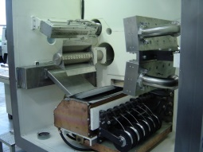
Figure 14 A photo of the various rolls inside the R2R tool

Impact of the WAFT Project in 2017
- The findings of the WAFT collaboration contributed to some non-academic outputs specifically towards developing tools and techniques to commercialize displays, especially by the involvement of Bodle Technologies Limited.
- Furthermore, a materials list was compiled via the Co-I at Southampton which has been circulated to industrial partners keen to take up any materials deposition on their chips for further integration. This could lead to breakthroughs in disruptive optoelectronic devices.

